**Tables:**

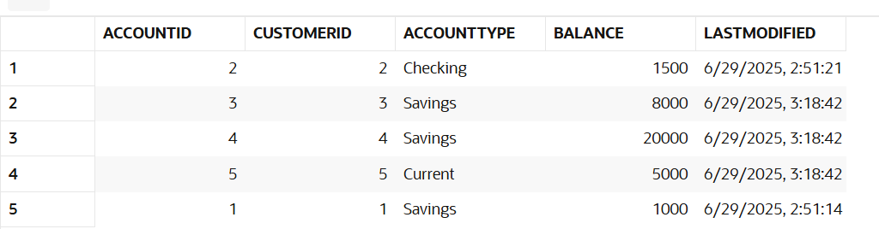

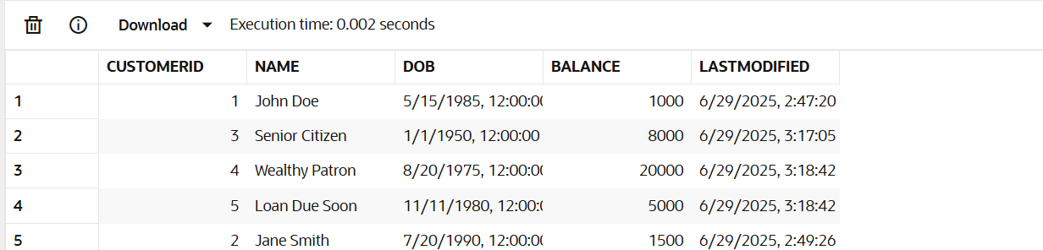

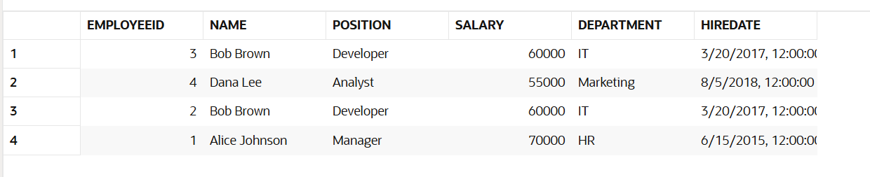

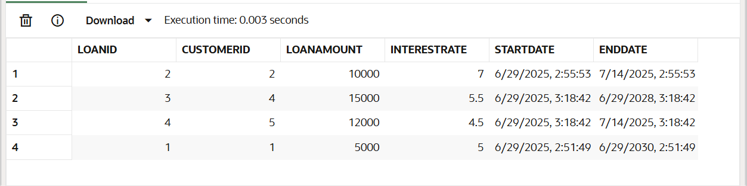

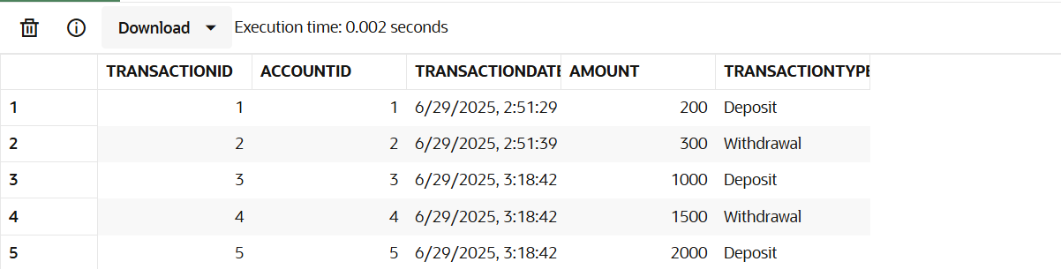

**Scenario 1: Process Monthly Interest for All Savings Accounts**

**PL/SQL Code:**

CREATE OR REPLACE PROCEDURE ProcessMonthlyInterest IS

BEGIN

    FOR acc IN (

        SELECT AccountID, Balance

        FROM Accounts

        WHERE AccountType = 'Savings'

    ) LOOP

        UPDATE Accounts

        SET Balance = Balance + (acc.Balance * 0.01)

        WHERE AccountID = acc.AccountID;

    END LOOP;

END;

BEGIN

    ProcessMonthlyInterest;

END;

SELECT * FROM Accounts;

**Output:  
 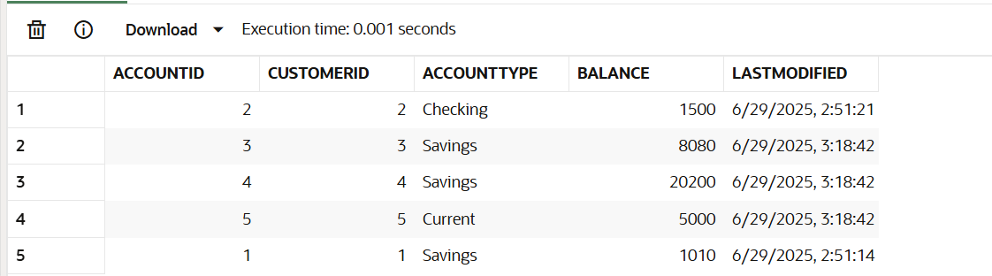**

**Scenario 2: Bonus for Employees by Department**

**Code:**

CREATE OR REPLACE PROCEDURE UpdateEmployeeBonus (

    dept_name IN VARCHAR2,

    bonus_percent IN NUMBER

) IS

BEGIN

    UPDATE Employees

    SET Salary = Salary + (Salary * (bonus_percent / 100))

    WHERE Department = dept_name;

END;

BEGIN

    UpdateEmployeeBonus('IT', 10);

END;

SELECT * FROM Employees;

**Output:**

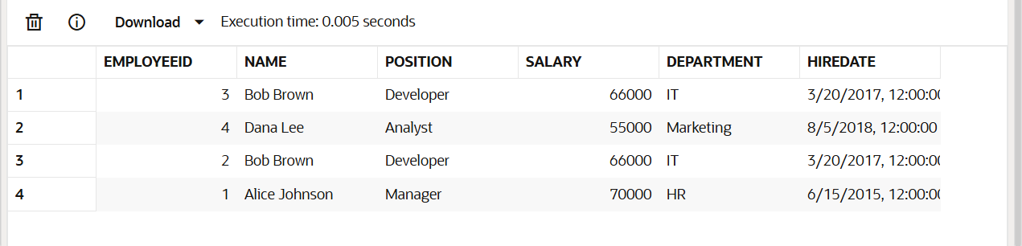

**Scenario 3: Transfer Funds Between Accounts**

**Code:**

CREATE OR REPLACE PROCEDURE TransferFunds (

from_acc IN NUMBER,

to_acc IN NUMBER,

amt IN NUMBER

) IS

from_balance NUMBER;

BEGIN

SELECT Balance INTO from_balance FROM Accounts WHERE AccountID = from_acc;

IF from_balance < amt THEN

RAISE_APPLICATION_ERROR(-20001, 'Insufficient funds in source account.');

END IF;

UPDATE Accounts SET Balance = Balance - amt WHERE AccountID = from_acc;

UPDATE Accounts SET Balance = Balance + amt WHERE AccountID = to_acc;

END;

BEGIN

TransferFunds(1, 2, 500);

END;

SELECT AccountID, Balance FROM Accounts WHERE AccountID IN (1, 2);

**Output:**